Eye Rhyme (Visual Rhyme)

🔹 What is Eye Rhyme (Visual Rhyme)
# Source: AI Source: Provided by: [Data Path: Persons Table -> ID Column: 1, Name_En Column: Motasem Essam] -> From: [Chatgpt (GPT-4-turbo)] on [8/1/2025]
An eye rhyme (also called visual rhyme) occurs when two words look like they should rhyme because of their spelling, but they do not sound the same when spoken.
The rhyme works visually, but not phonetically.

🧱 Key Feature
# Source: AI Source: Provided by: [Data Path: Persons Table -> ID Column: 1, Name_En Column: Motasem Essam] -> From: [Chatgpt (GPT-4-turbo)] on [8/1/2025]
- Spelling similarity creates the illusion of rhyme.
- Pronunciation is different, often due to irregularities in English spelling or historical shifts in pronunciation (e.g., the Great Vowel Shift).

📝 Examples
# Source: AI Source: Provided by: [Data Path: Persons Table -> ID Column: 1, Name_En Column: Motasem Essam] -> From: [Chatgpt (GPT-4-turbo)] on [8/1/2025]
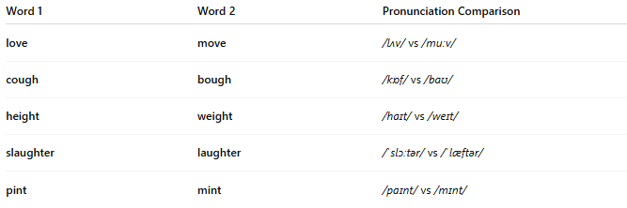
Word 1 | Word 2 | Pronunciation Comparison
love | move | /lʌv/ vs /muːv/
cough | bough | /kɒf/ vs /baʊ/
height | weight | /haɪt/ vs /weɪt/
slaughter | laughter | /ˈslɔːtər/ vs /ˈlæftər/
pint | mint | /paɪnt/ vs /mɪnt/

🎨 Poetic Use
# Source: AI Source: Provided by: [Data Path: Persons Table -> ID Column: 1, Name_En Column: Motasem Essam] -> From: [Chatgpt (GPT-4-turbo)] on [8/1/2025]
- Often unintentional or used for visual symmetry.
- Can create surprise, irony, or visual wordplay.
- Sometimes used in older poetry, where the words may have rhymed historically, but no longer do.

🔄 Historical Context
# Source: AI Source: Provided by: [Data Path: Persons Table -> ID Column: 1, Name_En Column: Motasem Essam] -> From: [Chatgpt (GPT-4-turbo)] on [8/1/2025]
Some eye rhymes used to be true rhymes but pronunciation changed over time.
- Example: move / love may have sounded closer in Middle English.

⚠️ Not a True Rhyme
# Source: AI Source: Provided by: [Data Path: Persons Table -> ID Column: 1, Name_En Column: Motasem Essam] -> From: [Chatgpt (GPT-4-turbo)] on [8/1/2025]
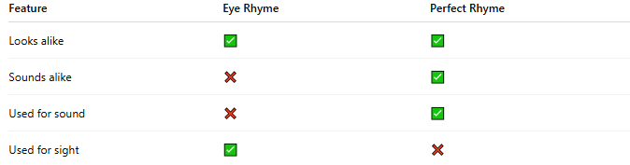
Feature | Eye Rhyme | Perfect Rhyme
Looks alike | ✅ | ✅
Sounds alike | ❌ | ✅
Used for sound | ❌ | ✅
Used for sight | ✅ | ❌

👁️ Common in
# Source: AI Source: Provided by: [Data Path: Persons Table -> ID Column: 1, Name_En Column: Motasem Essam] -> From: [Chatgpt (GPT-4-turbo)] on [8/1/2025]
- English poetry with archaic or traditional forms
- Poetic works where visual aesthetics are emphasized
- Silent letters or irregular spellings in English

